ICTCS 1310

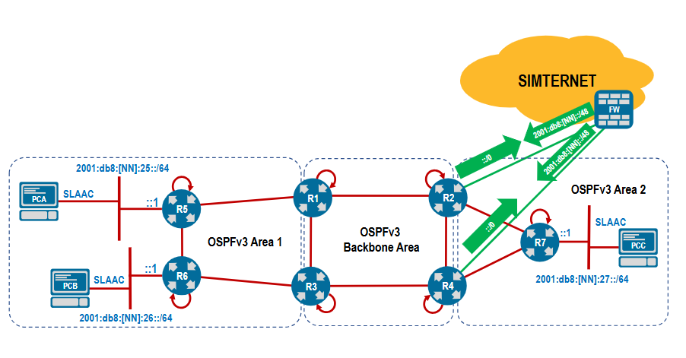

router ospf 1
distance ospf intra-area 105
distance ospf inter-area 105
end

router ospfv3
router-id 192.168.0.1
auto-cost reference-bandwidth 100000
passive-interface default
area 0.0.0.1 stub
area 0.0.0.2 stub no-summary
!
address-family ipv4
!
address-family ipv6

!

interface Lo0
ospfv3 ipv4 area 0.0.0.0
ospfv3 ipv6 area 0.0.0.0
!
interface eth1-3
no ospfv3 passive-interface

!
interface eth1-2
ospfv3 ipv4 area 0.0.0.0
ospfv3 ipv6 area 0.0.0.0
!
interface eth3
ospfv3 ipv4 area 0.0.0.1
ospfv3 ipv6 area 0.0.0.1
!

R2 ja 4
router ospfv3
router-id 192.168.0.4
auto-cost reference-bandwidth 100000
passive-interface default
area 0.0.0.1 stub
area 0.0.0.2 stub no-summary
!
address-family ipv4
!
address-family ipv6

!

interface Lo0
ospfv3 ipv4 area 0.0.0.0
ospfv3 ipv6 area 0.0.0.0
!
interface eth1-3
no ospfv3 passive-interface
!

interface eth1-2
ospfv3 ipv4 area 0.0.0.0
ospfv3 ipv6 area 0.0.0.0
!
interface eth3
ospfv3 ipv4 area 0.0.0.2
ospfv3 ipv6 area 0.0.0.2
!

R5
router ospfv3
router-id 192.168.0.6
auto-cost reference-bandwidth 100000
passive-interface default
area 0.0.0.1 stub
area 0.0.0.2 stub no-summary
!
address-family ipv4
!
address-family ipv6

!

interface Lo0
ospfv3 ipv4 area 0.0.0.1
ospfv3 ipv6 area 0.0.0.1

interface eth1-2
no ospfv3 passive-interface

interface eth1-2
ospfv3 ipv4 area 0.0.0.1
ospfv3 ipv6 area 0.0.0.1
!
interface eth3
ipv6 address 2001:db8:46:25::1/64
ospfv3 ipv4 area 0.0.0.1
ospfv3 ipv6 area 0.0.0.1
!

r7
router ospfv3
router-id 192.168.0.7
auto-cost reference-bandwidth 100000
passive-interface default
area 0.0.0.1 stub
area 0.0.0.2 stub no-summary
!
address-family ipv4
!
address-family ipv6

!

interface Lo0
ospfv3 ipv4 area 0.0.0.2
ospfv3 ipv6 area 0.0.0.2
!
interface eth1-2
no ospfv3 passive-interface
!

interface eth1-2
ospfv3 ipv4 area 0.0.0.2
ospfv3 ipv6 area 0.0.0.2
!
interface eth3
ipv6 address 2001:db8:46:22::1/64
ospfv3 ipv4 area 0.0.0.2
ospfv3 ipv6 area 0.0.0.2
!

r2
router ospfv3
address-family ipv4
default-information originate

r2

ipv6 route ::/0 2001:db8:0:1::
r4

ipv6 route ::/0 2001:db8:0:2::
sh ospfv3 database

r2 ja 4
router ospfv3
address-family ipv4
default-information originate metric-type 1

r2 ja r4 step2

start route
ipv6 routing 2001:db8:46:666::1

kaikkiin reitittimiin step3

router ospf 1
shutdown

ip ospf area 0.0.0.0

ipv6 route 2001:db8:26:666::1

ipv6 address 2001:db8:46:26::1/64

router ospfv3
address-family ipv6
default-information originate metric-type 1

